How to Run bioTabs Apps

1. **Checkout the project from SVN**
2. **If you expand src up to any App class (i.e. PpsBiotaberApp.java), you will notice eclipse doesn’t recognize as Java Application yet.**  
   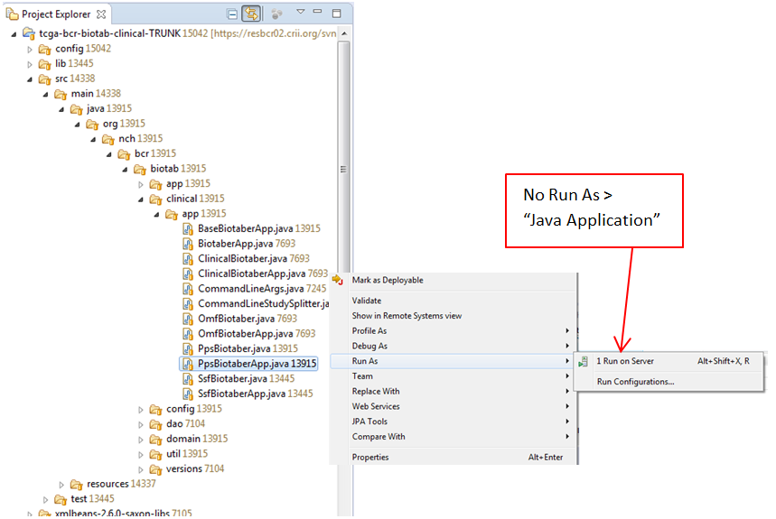
3. **Convert project as “faceted”** 
   1. Right click on the project name and click on “Properties”.  
      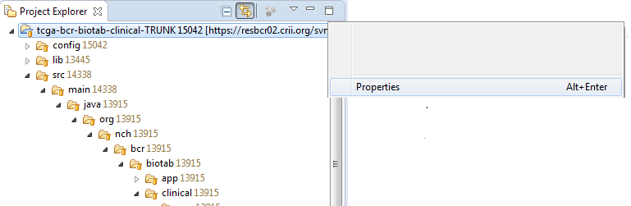
   2. On Left menu, click on “Project Facets”, and click on the link “Convert to faceted form.  
      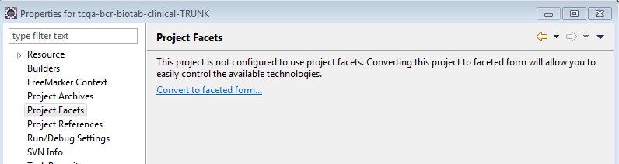
   3. Only select the “Java” checkbox, make sure it’s using the right Java version, and click OK.  
      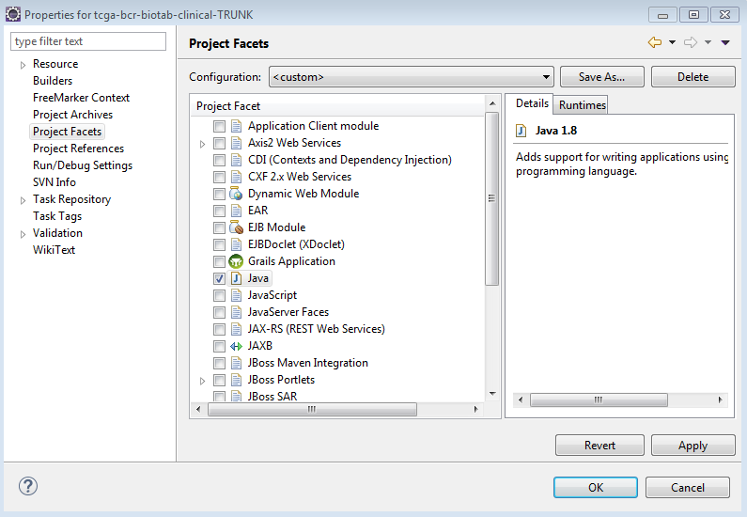
4. **Convert to Maven project**
   1. Right click on the project name and click on “Properties”.  
      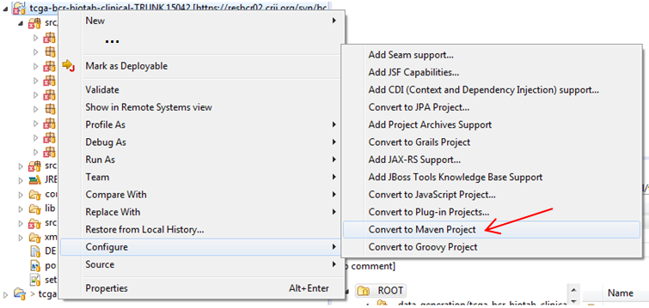
5. **Edit** *clinical_biotab_properties_qc* **to point to your local environment.**  
   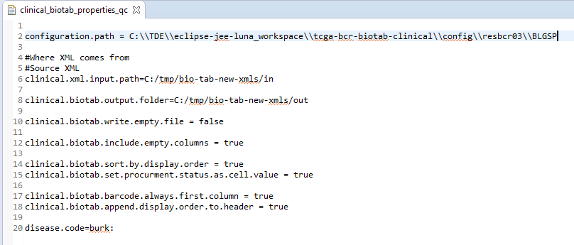
6. **Edit** xsdVersions.xml**, replace Major/Minor/Patch versions.**  
   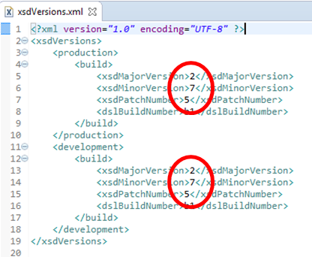
7. **Edit your pom.xml, update the value for** *xsd.xmlbeans.clinical.version***, same value as setp 6.**  
   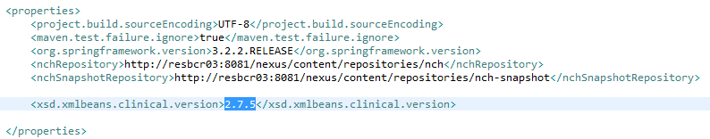
8. **Run As > Java Application (won’t work yet)**

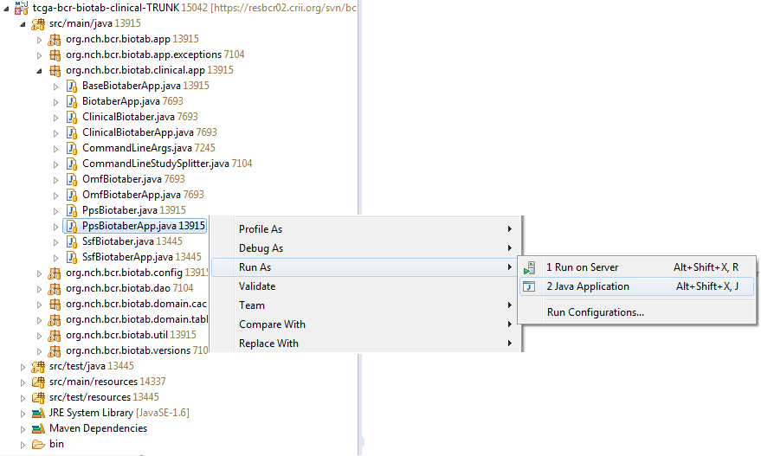  
This will throw an exception, but will create a “Run configuration” option. ;)

1. Click on the arrow (black) next to Run button, select Run Configurations  
   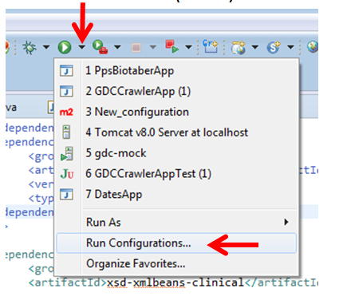
2. Enter program argument “propPath”.  
   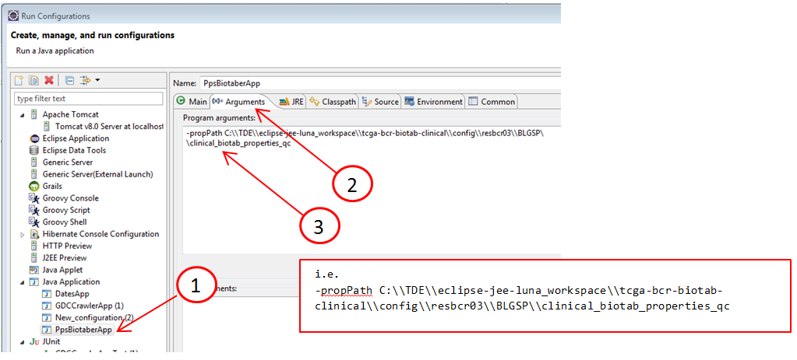
3. **Run As > Java Application**

TROUBLESHOTING

# Issue ClassNotFoundException: nci.tcga.bcr.xml.xmlbeans.prescreen_2_7_14.TcgaBcrDocument$Factory

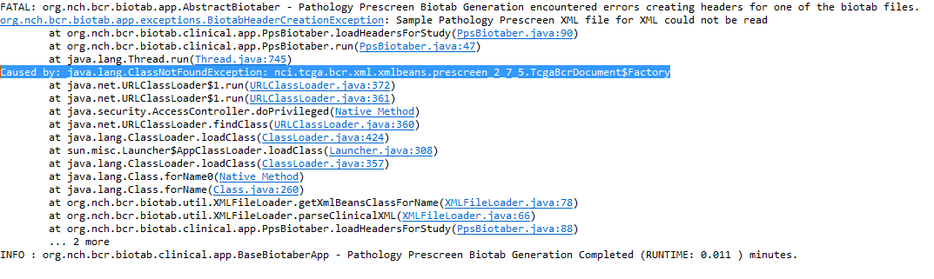

# Solution

Add .jar to classpath in eclipse.

1. Click on the arrow (black) next to Run button, select Run Configurations  
   
2. Under “Java Application” (left menu), select the class that you want to run,   
   then select “Classpath” tab.  
   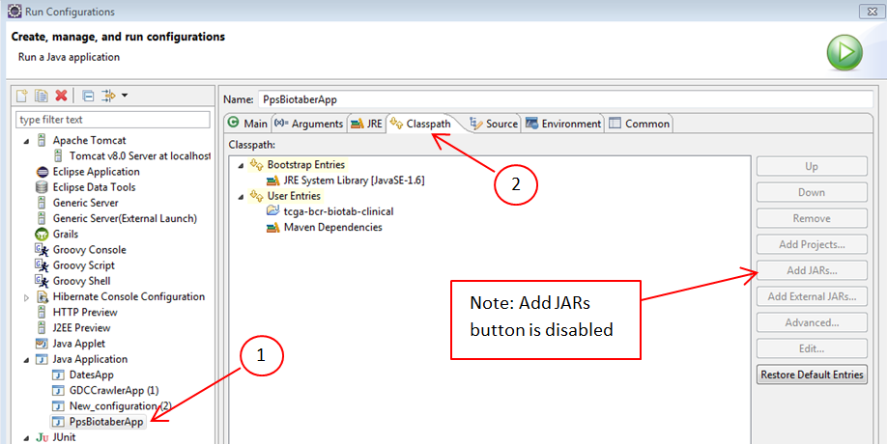
3. Click on “User Entries” to enable Add JARs button. 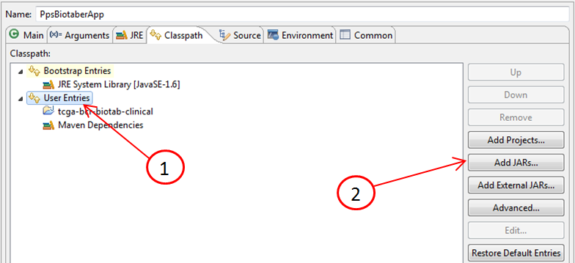
4. Expand the project and folder where the .jar is, select the .jar and click OK.   
   